Logan Nagel
Medici Florence
From Piety to Power: Medici Religious Patronage
The biblical story of the Transfiguration describes Jesus revealing his divine nature to a few of his closest disciples. It is Jesus transcending his current self and showing a glimpse of his true nature. This story serves as a fitting metaphor to how the Medici developed their patronage of art during the period 1400-1600 A.D. The Medici transfiguration is represented in the messages of its religious art and architecture. It was a gradual process, but with each generation the Medici became ever more present in their religious art and the virtues espoused by these works transitioned from piety and righteous wealth to power and nobility. Within two centuries, the Medici would take the shockingly modern idea of using art as publicity and take it to a shocking conclusion: depicting themselves not only as nobles, but as gods. By analyzing four works of art during different periods of Medici dominance, patterns emerge that indicate religious art changed from a preferred medium to a tool for propaganda.
Cosimo the Elder’s legacy is encapsulated by a prominent nickname: pater patriae (father of the fatherland). The godfather of the Medici line, his major forays into patronage included sponsoring Donatello’s David and the tomb of Baldassare Cossa. Surpassing either of these endeavors, however, was his sponsorship of the design and construction of the Duomo (Figure 1). While most of the structure was complete before Cosimo was born, the lack of a finishing dome was a disgrace to the Florentine people, and they desired for it to be completed (PBS). While it may seem implicit, one of the most significant things about Cosimo’s sponsorship was that he was even able to sponsor such a large public work. This wasn’t the first time it was done, but setting the precedent of using wealth to aid in the common good was a milestone in Medici history. While there was certainly a civic interest in helping financing the project, there was also a hint of self-interest in his sponsorship of the Duomo (Parks). While Cosimo’s face would not adorn the church, and the Medici name wouldn’t be carved over the dome for all of Florence to see, it would be generally known who contributed the funds to complete it. Cosimo additionally backed the creation of the Ospidale Degli Innocenti, an orphanage that would demonstrate Roman arches and classical techniques unseen for hundreds of years. The Duomo would be a concrete representation of Medici financial power, and make a statement about the civic and religious commitments of the Medici family. The construction of the Duomo and the orphanage weren’t subtle ways to improve the image of the Medici, but it was an seemingly selfless way for the Medici to announce their arrival as a powerful political and financial force in Florence. From the beginning, the Medici family used religious art as a tool to advance their desired image, which in this case was that of a financial powerhouse on the rise.
Cosimo’s grandson, Lorenzo the Magnificent, continued his family’s tradition of patronage and took an important step towards modernity through his sponsorship of the Magi Chapel in the Palazzo Medici Riccardi (Figure 2). It is in this piece that the Medici subtly insert themselves into an iconic piece of Christian history. The piece was painted by Benozzo Gozzoli and covered several walls with the biblical story of the three wise men (magi) delivering gifts to the baby Jesus. The Medici take form not as the magi themselves, but as members of the procession. Cosimo the Elder, his son Piero, and a young Lorenzo can be seeing following the wise men. Each of them are adorned with rich fabrics and jewels. Of particular significance is the use of lapus lazuli stone being used in the adornment of this piece, further cementing the image of the Medici as rich and powerful. The Medici coat of arms appears near the depictions of the family members, to further ensure that passersby know who exactly is being shown next to biblical paragons of piety. It is a fascinating choice for the Medici to pick the story of the Magi to insert themselves in; it is a choice that they would do multiple times throughout their rule, and is likely due to the magi being one of the few positive depictions of the wealthy within the Bible. As alluded, specific traits of the Medici are made as obvious as possible for people to observe. Piety is characterized by Piero riding a donkey; Medici family members are adorned with jewels to show wealth and power (perhaps contradicting the previous point); the background for the painting is heavily inspired by the Florentine hills to indicate the glory of the city. The important steps of depicting the Medici themselves in religious art to solidify their connection to the piece and make statements about their qualities are a significant change from Cosimo’s brand of artistic publicity.
The Portrait of Pope Leo X by Raphael is potentially the greatest depiction of Medici papal power ever made (Figure 3). While the Last Judgment would be the most iconic piece of papal art from the time of the Medici popes, Clement VII died before his vision of the mural could be finished. The centerpiece of the picture is Pope Leo X himself, sitting in his papal robes gazing at someone who has entered the room. Within the piece, a “dynasty” of Medici control of the Vatican is shown through Giulio de Medici (Clement VII) firmly grasping the chair Leo is sitting in. On top of the chair is a palle, reminiscent of the Medici coat of arms (Khan Academy). The Bible in front of Leo is the Hamilton Bible, notable for having been owned by Lorenzo the Magnificent, creating another visual connection to the Medici name. In Leo’s left hand is depicted a magnifying glass, indicating careful study of the Bible and implying an unwavering interest in theology. Portraits had certainly been done of Medicis before, but the religious significance of this piece makes it stand out. Not only is it a religious work, with two Medici popes and a bible, it is also a piece of subtle propaganda. A man other than the pope firmly grasping the chair of God’s word on earth is a powerful statement. Hints to the Medici family within the piece such as palles on the papal chair and Hamilton Bible leave no doubt that the man holding the key to heaven is a Medici. While Raphael’s depiction of Pope Leo X is a piece of religious history and serves that purpose through striking realism of his unflattering physique, it is equally a piece of publicity for the Medici family. Cosimo the Elder likely would have balked at putting the family name so far out into the spotlight, while art in the era of Lorenzo tentatively placed Medicis in the entourage of biblical figures. This penultimate step towards modernity and self-divination was extremely significant if only for the depiction of someone laying claim to an otherworldly office…and the aggressor was a Medici.
The final Transfiguration of the Medici took place under the rule of Cosimo I, Grand Duke of Tuscany. The Medici had envisioned themselves as patrons of churches, members of biblical processions, and even as a dynasty of popes with a firm grapple on the Vatican. While claiming to be nobles and popes, however, they had not claimed to be rulers or gods. This is precisely what happened in Vasari’s depiction of The Apotheosis of Cosimo I de Medici (Figure 4). It is in this piece, with Florence as his disciples, that the Grand Duke would crown himself a god. The Apotheosis is on the ceiling of Salone dei Cinquecento in Florence. The placement in itself is brilliant: forcing any viewer to gaze upwards to the actual heavens to see the full work. Cosimo I is the centerpiece, and is coroneted by an angelic cherub while dozens of others watch in joy. He is wearing the color purple, symbolic both of royalty and of Jesus Christ. He lives among the clouds, implying that he has transcended a human form and has risen to a new level of existence. To top off the piece, he receives the cross of St. Stephen, the first martyr. All of this symbolism is only enhanced by the décor of the walls holding it up. The room in which the Apotheosis is located is largely devoted to historical events in Florentine history, implying reality to an obviously over the top piece of propaganda. Religious imagery, in this piece, has made a full transition to a tool for propaganda. Whereas earlier Medicis had used religious art as an opportunity to promote themselves, they have never implied outright royalty or godhood. The Apotheosis took the innate desires of fame and power and removed all religious pretexts. This work was pure propaganda, and religious was a means to an end rather than a medium.
While these artistic projects show a clear transition from public art to propaganda, it was not a completely linear process. Lorenzo de Medici had been depicted with the Madonna as a child years before the Apotheosis of Cosimo I. There is, however, a definite trend of public art transitioning to propaganda. There is also a trend of the Medici changing their messaging from piety and wealth to power and nobility. Physically, the art transitioned from the Medici being physically invisible from the Duomo to being at the center of the Apotheosis. The Medici’s patronage to religious art changed over time as well; the early Medici are seen as members of a procession during the time of Lorenzo and become an intimidating depiction of a papal dynasty but a generation later. On a large scale, the change in how the Medici patronized religious art gives insight into how their patronage changed on a larger scale. During the time of Cosimo and Lorenzo, public art and building the city was seen as a way to please the people and secure a reputation for a blossoming family line; during the time of the popes and the grand dukes, however, any medium or subject matter was used as a tool to promote an air of nobility and divine right. This tremendous change came over time, and the use of art as a tool to create an image never changed. As aspirations increased, subtlety decreased. By the time of the Apotheosis, the Medici had fully transfigured into a thoroughly modern dynasty.

Figure 1
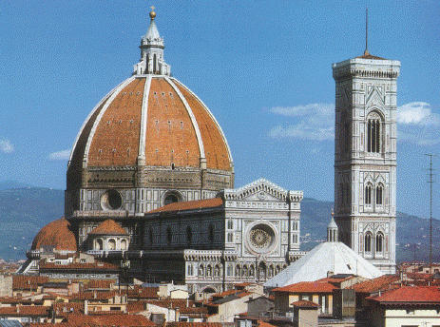

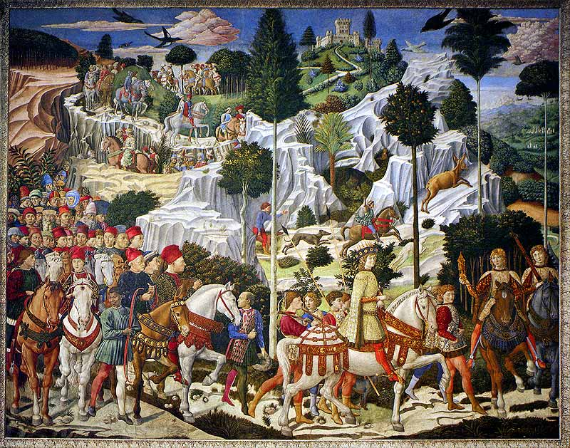
Figure 2
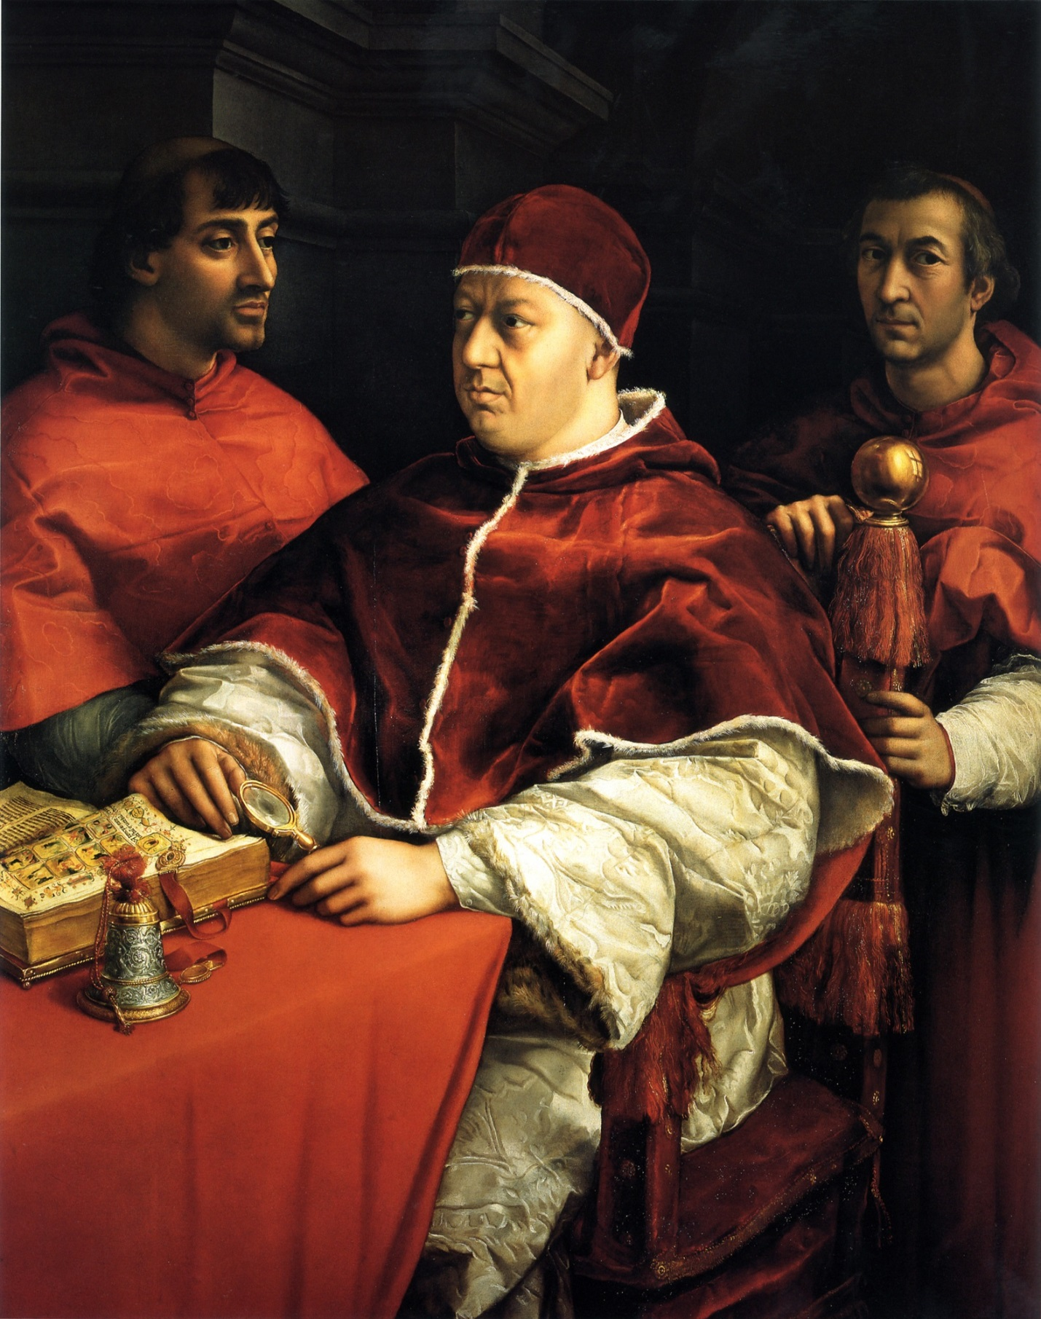
Figure 3
Figure 4
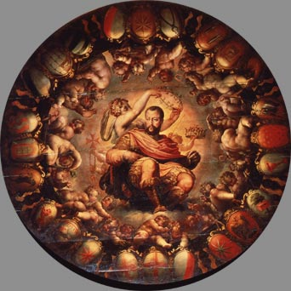

Works Cited
"Magi Chapel." Wikipedia. Wikimedia Foundation, n.d. Web. 30 Apr. 2015.
"Chapel of the Magi - Florence." Chapel of the Magi - Florence. N.p., n.d. Web. 30 Apr. 2015.
Parks, Tim. Medici Money: Banking, Metaphysics, and Art in Fifteenth-century Florence. New York: W.W. Norton, 2005. Print.
"The Procession of the Magi." Mediateca Di Palazzo Medici Riccardi. Provence of Florence, n.d. Web. 29 Apr. 2015.
"Florence Cathedral." Wikipedia. Wikimedia Foundation, n.d. Web. 30 Apr. 2015.
"Il Duomo." Brunelleschi's Dome. N.p., n.d. Web. 30 Apr. 2015.
"Portrait of Leo X (Raphael)." Wikipedia. Wikimedia Foundation, n.d. Web. 30 Apr. 2015.
"Portrait of Leo X (Raphael)." Khan Academy. Khan Academy, n.d. Web. 30 Apr. 2015.
"Apotheosis of Cosimo I De' Medici (1519-74) from the Ceiling of the Salone Dei Cinquecento, 1565 Giclee Print by Giorgio Vasari at Art.com." Art.com. N.p., n.d. Web. 30 Apr. 2015.
"Transfiguration of Jesus." Wikipedia. Wikimedia Foundation, n.d. Web. 30 Apr. 2015.
"Medici: Godfathers of the Renaissance." PBS. PBS, n.d. Web. 30 Apr. 2015.
"Saint Stephen." Wikipedia. Wikimedia Foundation, n.d. Web. 30 Apr. 2015.
Images
http://upload.wikimedia.org/wikipedia/commons/6/67/Santa_Maria_del_Fiore.jpg
http://upload.wikimedia.org/wikipedia/commons/b/be/Gozzoli_magi.jpg
http://upload.wikimedia.org/wikipedia/commons/0/0f/Raffael_040.jpg
https://www.google.com/culturalinstitute/asset-viewer/apotheosis-of-cosimo-i/XwFuoYF7s8xVng?hl=en

